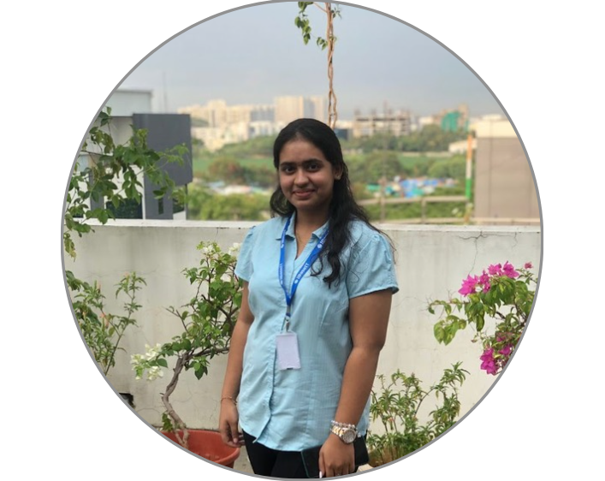

Anisha Paturi

Student
Phone: +91 8639781680
paturi.anisha@gmail.com
www.linkedin.com/in/anisha-paturi-8b885a2b5
https://github.com/AnishaPaturi

Core Skills
- Front End: HTML, CSS, JS, React
- Middle Tier: C, Java, Python, C++
- Back End: MySQL, MongoDB, Express.js, Node.js
- Frame Works: BootStrap, SpringBoot
  - AI/ML: Machine Learning, Deep Learning, Transformers, GenAI, Streamlit
- Agentic AI: (LangChain, LanGraph)

Education
BTech – CSE (8.6 CGPA), KMIT, Hyderabad (2023- 2027)

Passionate Computer Science Engineering student at KMIT (CGPA 8.6) with hands-on experience in full-stack and AI-driven development. Skilled in the MERN stack, Java, and Python, with internship experience at IBaseIT and ODT. Dedicated to building scalable, intelligent solutions that create real-world impact.

WORK EXPERIENCE

INTERNSHIP EXPERIENCE

IBaseIT (May ‘24 – June’24)
GradeSync is a student grade management system that uses Python, PHP, and SQL to add, display, and calculate student grades efficiently. It streamlines managing student data and class averages through a web-based interface.
Tech Stack: Python, HTML, CSS, MySQL
https://github.com/AnishaPaturi/GradeSync

ODT (April ‘25 – June’25)
PythonLonden is a project that transforms the PHP Symfony 1-based Londen’s Campaign Manager into Python, aiming to enhance maintainability and performance. The original system offers dashboards for mailed campaigns, response tracking, and data visualization.
Tech Stack: Python
https://github.com/AnishaPaturi/PythonLonden
.
Projects:
Ctrl+S of Shame (March ’26)
A comprehensive AI driven mental wellness application designed to help users track their moods, manage wellness, and connect with psychiatrists. Built with modern web technologies for a seamless user experience.
Tech Stack: TypeScript, VS Code Extension API, Node.js
(Available on VS Code Marketplace)

Network Security Toolkit (March ’26)
Built a Java-based network security toolkit capable of performing multithreaded port scanning, banner grabbing, LAN host discovery, and live packet capture using the Pcap4J library. Implemented socket-based scanning to detect open services

COLLEGE ENGAGEMENT
- Participated in VJIT Hackathon, 2023
- Attended a workshop IITH for Gen AI course
- Worked as Volunteer for DBMS Workshop in KMIT, 2024
- Worked as Volunteer in NMDC Hyderabad Marathon, 2024
- Participated in a Product Space Hackathon, 2025

Other Details
Domicile: Hyderabad, India
Languages: English, Telugu, Hindi

(HTTP, HTTPS, SSH) and developed a packet analyzer that extracts source IP, destination IP, protocol type, and packet size from real-time traffic.
Tech Stack: Java, Socket Programming, Multithreading, Pcap4J, Npcap
https://github.com/AnishaPaturi/network-port-scanner.git

Mood Angles (Aug ‘25 – Ongoing)
Developed and published a VS Code extension that detects errors on file save and debug events using the VS Code Diagnostics API. Deployed to the Visual Studio Code Marketplace.
Tech Stack: React, Python, Agentic AI, MongoDB, Express.js, Node.js
https://github.com/AnishaPaturi/Mood-Angles

Safe Street (April ‘25 – June’25)
SafeStreet is an AI-powered platform that detects, reports, and manages road damage via mobile and web interfaces. It enables users to capture images of potholes/cracks, auto-classifies severity, sends reports, and gives authorities a dashboard to track & act.
Tech Stack: React, Transformers, MongoDB, Node.js, Express.js
https://github.com/AnishaPaturi/SafeStreetApplication

Campus Connect (Jan ‘25 - June ‘25)
College-Connect is a web platform that unifies campus life by offering students access to events, announcements, study resources, and forums in one place. It streamlines college communication, giving admins tools to manage content while students stay plugged into academic and social updates.
Tech Stack: HTML, CSS, Java Script, MongoDB, Express.js, Node.js
https://github.com/AnishaPaturi/College-Connect

Talent Match (Nov ‘24 – Dec ‘24)
Talent-Match is a platform where users post problems or skill-based queries, and the system matches them with knowledgeable individuals. If someone accepts, they collaborate on a shared interface to solve the issue together.
Tech Stack: HTML, CSS, Java Script, MongoDB, Express.js, Node.js
https://gitub.com/AnishaPaturi/Talent-Match

